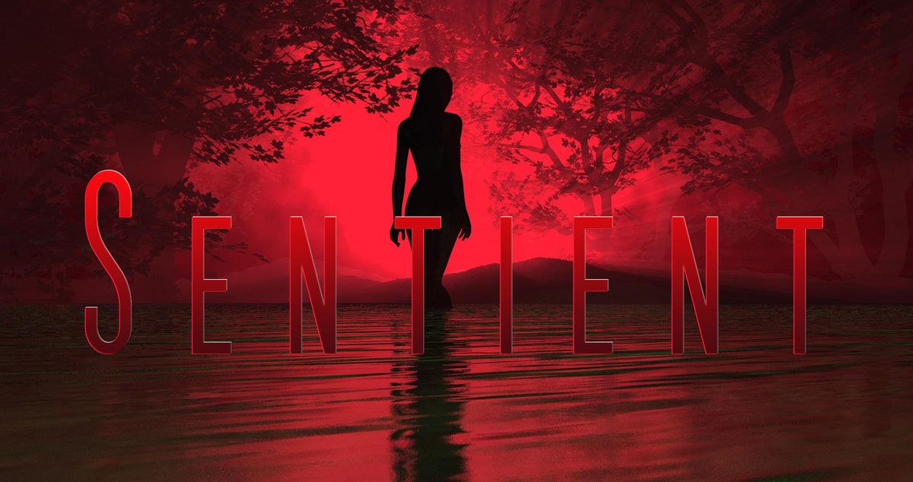

Sentient USA – Ten questions from the Author Joseph DiFrancesco

Please download the document and add you answers under the Qs.

- Does the hook, (the inciting incident of the storm) immediately grab the reader?

2) Are the individual set-ups (supporting character scenarios) compelling?

3) Are any of the characters lacking in the ability to create viewer empathy?

4) A slow arc is being created. What short or long distant evolution do you see, or can you envision for certain characters?

5) Is the overall pace effective?

6) Are Sentient being under or over introduced?

7) What scenes need improvement? Why? How?

8) What scenes are the strongest? Why?

9) What direction/s do you see USA going in?

10) What direction should be avoided?

- Yes. It’s right in the moment – great!
- Yes, you have given life and motivation.
- Give Joey a little more screen time so his death has greater impact and means more to the others.
- If Carolyn and Damien get to meet Jenny they could sort of transfer their feelings about losing Joey onto her.
Motivation for JJ to find his fiance is strong but I can see things going against him – maybe he’ll lose her or fall prey to Sentient shenanigans.
They’re all in little groups, so far, so their coming together could upset those dynamics – is it help or hindrance?
- Yes, well paced.
- Just a hint, so I think you’re doing it right.
- I may have missed something, but I didn’t think Lena knew Reese needed glasses. Maybe make more of this – stronger examples of hindered eyesight that would alert her.
- Strongest scenes are those of immediate impact - JJ and Syd; Lena and her birthday disaster.
- I like the characters so far, so I see potential in them. I want to see if they make the right decisions and how they deal with the consequences of things going forward. Damian and Carolyn’s interest in freeing the animals is great, so I want to see how their reactions with Sentient go.
- The latter half feels like all the nasties come out of hiding. Maybe don’t overdo this like Walking Dead does; it can be overdone. But you have, at least, set up reasonable examples (so I’m just saying you should watch how this is done in future episodes).

Overall, a great script!

-Harley Woods.

