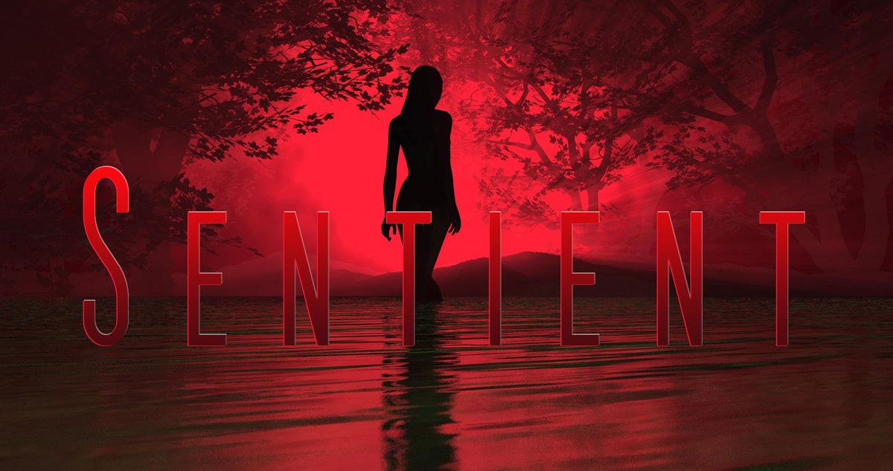

Sentient USA – Ten questions from the Author Joseph DiFrancesco

Please download the document and add you answers under the Qs.

- Does the hook, (the inciting incident of the storm) immediately grab the reader?

2) Are the individual set-ups (supporting character scenarios) compelling?

3) Are any of the characters lacking in the ability to create viewer empathy?

4) A slow arc is being created. What short or long distant evolution do you see, or can you envision for certain characters?

5) Is the overall pace effective?

6) Are Sentient being under or over introduced?

7) What scenes need improvement? Why? How?

8) What scenes are the strongest? Why?

9) What direction/s do you see USA going in?

10) What direction should be avoided?

