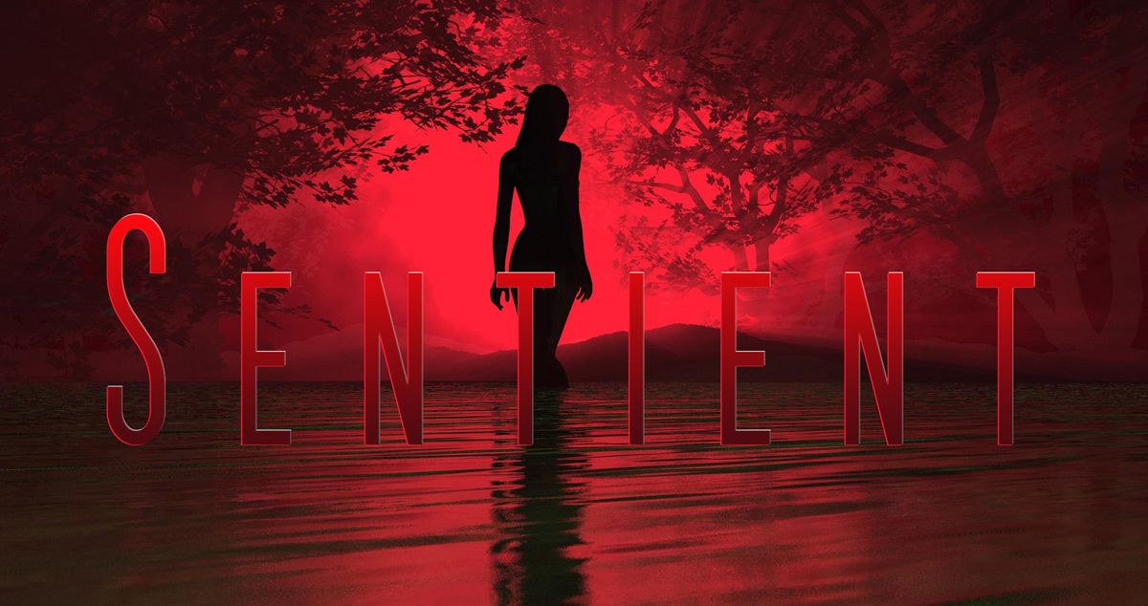

Sentient USA – Pilot Review

I Loved the script and I wanted to follow the characters. Great pacing throughout, with some really good points of drama, particularly for JJ.

As far as format / formula goes, it seems to include all of the necessary stuff and I think it hits the right points.

I might look at some of the dialogue again - a few points felt a bit unnatural, but otherwise fine. Just naturalize some of the speech here and there; mostly fine, though.

Characters:
Give Joey a little more screen time so his death has greater impact and means more to the others.

If Carolyn and Damien get to meet Jenny they could sort of transfer their feelings about losing Joey onto her. Give more reason for concern and attachment.

JJ is clearly the best realized character, at this point. Motivation for JJ to find his fiancé is strong but I can see that this could also lead to things going against him – maybe he’ll lose her or fall prey to Sentient shenanigans.

Sal was interesting, and I totally see him crossing JJ'S path again – especially now that JJ has crossed paths with escaped criminals which could give Sal an “I told you so” moment. Definitely more to see.

They’re all in little groups, so far, so their coming together could upset those dynamics – is it help or hindrance?

Occasionally I felt I’d missed something in Lena’s scenes, and Reese’s (and their combined journey). And possibly I did, so apologies if I make a redundant comment or two. Their journey feels like it has jumps, which I guess means nothing major happens. However, we do get them bonding which is nice. We should see more of it so that it builds more naturally – this could even be shown by them protecting each other in some situation or other.

Also, show more about Reese needing glasses, and turn it into an issue so that we see Lena becomes aware of it and so finds him the spectacles in the farm house.

Lena’s doomed birthday party and JJ’s ordeal with the death of Syd are great and powerful – I hope there is more of that throughout the series.

I also like the “ghost” of Syd appearing – maybe build up to this a tiny bit more than you have; post traumatic stress and JJ’s potentially fractured mind from the series of terrible events are going to be great elements to work with. And they slightly mirror the Australian script, which is nice.

I see potential in all of your characters, and have really liked them enough to be invested. I want to see if they make the right decisions and how they deal with the consequences of things going forward.

Damian and Carolyn’s interest in freeing the animals is great, so I want to see how their reactions with Sentient go. Do the Sentient see these actions and approve? Do they react to the Sentient differently to the others?

Fleshing out their relationship and putting more of Joey in will help their story. Joey, so far, is too “throw away” and doesn’t have a clear understanding or natural reaction to the situation they’re in.

Having all the "bad guys" appear toward the end of the script kind of felt a bit much, but they made good points (Jenny seeing the miners as the four horsemen), but just watch that they don't get too clichéd and don't amass too quickly (which is a problem with The Walking Dead).

But you have, at least, set up reasonable examples (so I’m just saying you should watch how this is done in future episodes).

The Sentient presence is well used, and just enough to raise curiosity and suspicion.

I wondered, at first, if the Black Woman was something too much, but no; I think she’s just right at the right time to remind us that something greater is going on that we just can’t understand yet.
I also liked the figure in the forest, too. I hope it appears again – how would it react to the inmates and Sal? Exciting thoughts.

I kind of wish Reese had done something to help the dog. Maybe if the dog was with him it could alert him and Lena when something otherworldly is going on. Might be nice drama for them to build their relationship.

Otherwise, I think this script is great and I look forward to seeing their journey. You have just enough Sentient hints to get my curiosity piqued, also. Well done.

3.5-4 stars.

Overall, a great script!

-Harley Woods.

