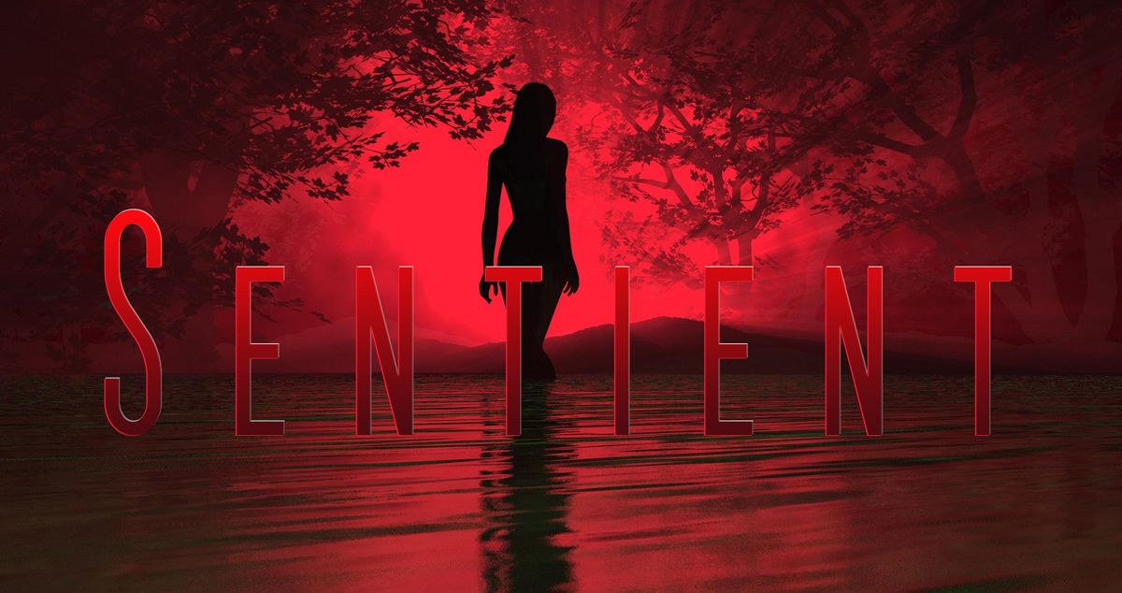

Sentient USA – Ten questions from the Author Joseph DiFrancesco

Responses from Geoff Dupuy-Holder

3 stars

Please download the document and add you answers under the Qs.

- Does the hook, (the inciting incident of the storm) immediately grab the reader?
The storm is effective, providing an immediate hook. I’d say more needs to be made of the red haze, and the physiological damage to the characters.

2) Are the individual set-ups (supporting character scenarios) compelling?
In general, yes. The zoo sequence however almost feels as if it belongs in episode 2. I like the idea of characters who care for animals (and how that will later work with the Sentients) but this episode seems crowded in. Either introduce it earlier or leave it until the next episode.

3) Are any of the characters lacking in the ability to create viewer empathy?
I feel JJ needs a bit more grit. As a hero he seems to be lacking a bit in purpose.

4) A slow arc is being created. What short or long distant evolution do you see, or can you envision for certain characters?

I can foresee that JJ’s problem with Lindsey will come to a head, perhaps when he discovers that Lindsey is either a Sentient, is targeted to mate with a Sentient, or has taken another path altogether. I can see that JJ will be tempted by another woman, and that will end up with him making bad judgments.

I can see Sal as ‘the right man’ – the one who takes over and does the killing no one else wants to do, eventually perhaps becoming a demagogue or clan leader. A righteous man from his own point of view. Perhaps he will link up with the miners.

Lena is potentially the most interesting – she is clearly damaged (the cutting etc.) and is the economic underdog, but has a good heart. She could easily become a co-leader with JJ.

Reese will have to find a role, possibly as a follower with a special skill. It’s not going to be electronics or digital, obviously, so what else can he do? Perhaps he is a quartermaster type, organising and planning resources?

Dallas could easily be a loose cannon, forming either a band of brigands, or become the enforcer for a religious leader (‘Sentient are demons’).

Damien (oh look, another character beginning with D) seems to have an affinity for animals. This could mean something when he encounters the Sentient.

5) Is the overall pace effective?
Yes-ish. It slows down in the middle, and the ticking clock of the dam is under-used, so when the dam breaks you don’t feel there’s been enough tension beforehand. I think the zoo sequence really slows it down towards the end, so as noted above, maybe it belongs in episode 2.

6) Are Sentient being under or over introduced?
Remove all the Sentient scenes scattered throughout, then, as per the guidelines, end on the big reveal.

7) What scenes need improvement? Why? How?
There’s details in my notes.
For the big picture –
give more strength to JJ’s goal and character;
tighten up the dialogue (and the action paragraphs);
either intro the zoo sequence earlier or move it to the next episode;
speed up the timeline – what if everything took place within 24-48 hours rather than over several days?
and boost up the ticking clock.
Lastly, lose ghost-Syd.

8) What scenes are the strongest? Why?
The storm works because it is well described in a dangerous setting.
The miners work because of the menace but I wasn’t sure of their motivation.
Shooting the trapped prisoner in the head is a real shock moment.
And I love the birthday hat – so incongruous in the circumstances.

9) What direction/s do you see USA going in?
I think we need to concentrate on the show’s USP – the Sentient. They are both the Monster and the Mentor in this story, and that is what will distinguish the show from other series. The stakes for individual characters should rise, but the stakes for humanity are even higher.

10) What direction should be avoided?
‘I’ve seen all this before’
‘Clichéd’
‘Safe’

